**Face Detection and Recognition using OpenCV**

**Created By:** Urvil Ashokkumar Patel (1131703)

Jhanvi Dilipkumar Upadhyay (1159217)

**Group No:** 09

**Guided By:** Dr. Jinan Fiaidhi

**Objective:** Our main objective is to detect and recognize the human face by using various algorithms and classifiers. We build an automated attendance system by using this technology and mark the attendance in an excel sheet. This mode of attendance system is more secure and easier than the manual as well as other means of attendance system.

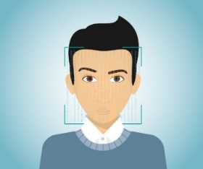

Mark the attendance in an excel sheet

Recognize face

Detect Face

**Problem Definition**: Nowadays, in most schools and colleges, student’s attendance is taken manually by using an attendance sheet in the classroom, which is time-consuming as well as increases the workload of a teacher. Moreover, it is very difficult to verify one by one student in a large classroom whether the authenticated students are responding or not.

**Requirements:** The following things should be installed on the system

* PyCharm: the Python IDE ( Alternative approach: jupyter notebook or google colab )
* Necessary libraries need to installed ( OpenCV, NumPy, xlwt )
* Web cam should work properly in respected system.

**Step 1:** First, we have to install the necessary libraries to achieve our goal. The basic libraries that we are going to use are OpenCV and NumPy. By using the pip command we can install these libraries in our workspace.

To install OpenCV, run the following command in the command prompt

**pip install opencv-python**

To run the LBPH algorithm, **opencv-contrib-python** library needed

**pip install opencv-contrib-python**

To install NumPy, run the following command in the command prompt

**pip install numpy**

To generate spreadsheet files using xlwt and doing basic editing like font colour, size etc. run the following command in the command prompt.

**pip install xlwt**

**Alternative approach for step 1:**

We can directly downloaded above mentioned libraries in our PyCharm IDE.

1. **Go to the File and select setting**



1. 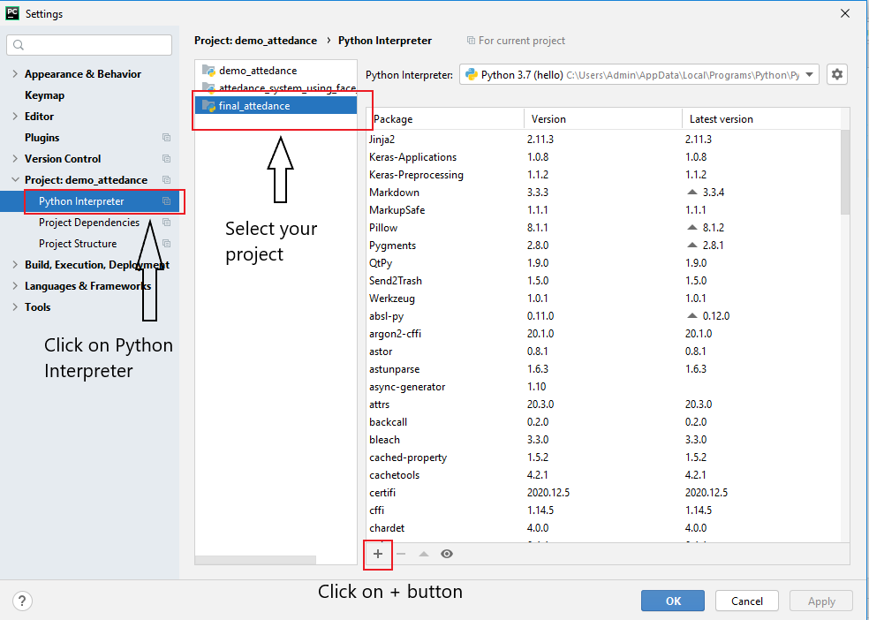**Select python Interpreter**
2. 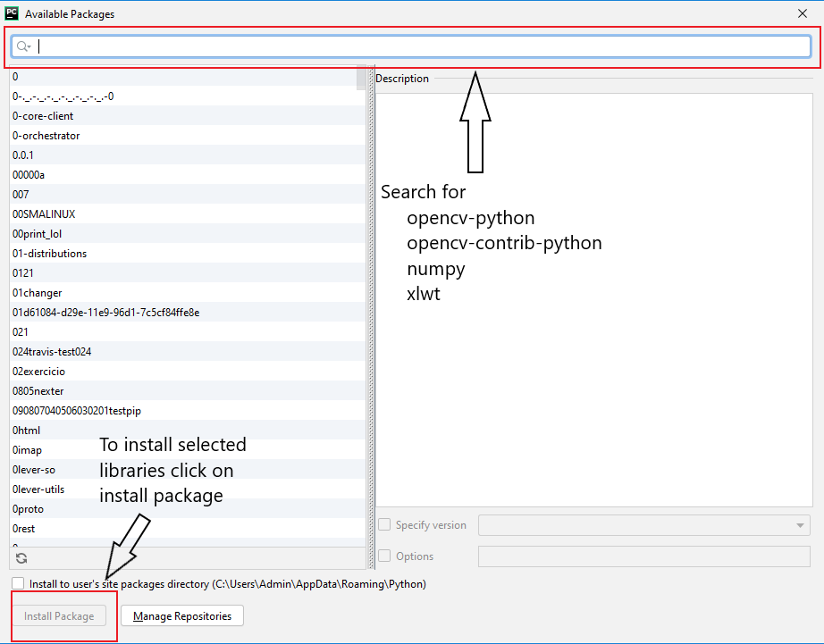**Search requires libraries and install it**

**Step 2:** After installing libraries, first, create one python file in the Python IDE. So, to detect any faces from the sensors (such as a camera), the camera will first capture the human image then cropped it and store it into the located database. It will also convert the RGB image into the grayscale image because it is very easy to detect facial features in the grayscale image. Moreover, we load the haarcascade_frontalface_default.xml file to recognize any human face from the images.

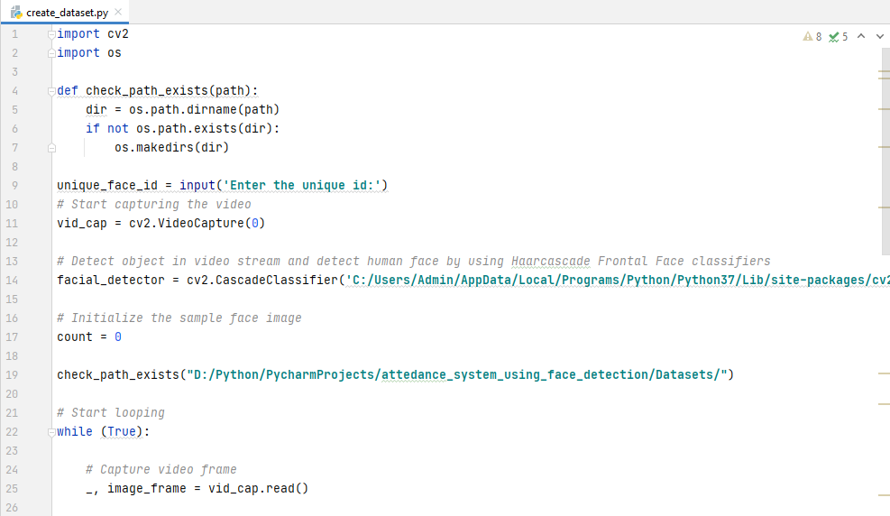**Filename:** create_dataset.py

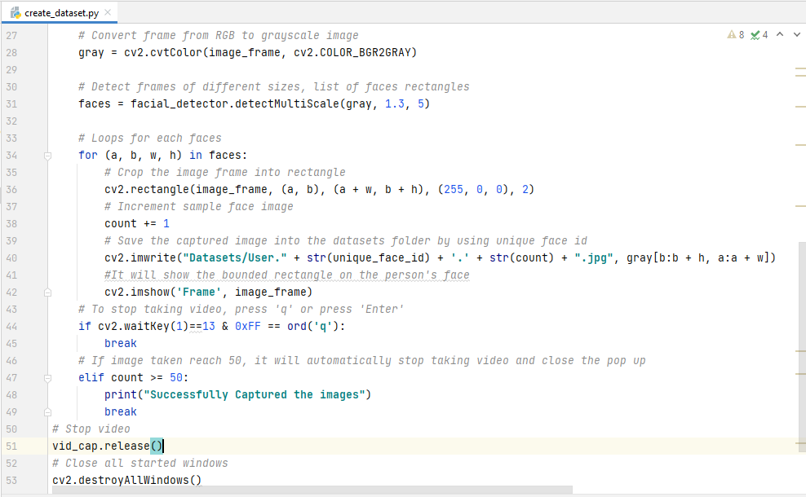

**Output:**

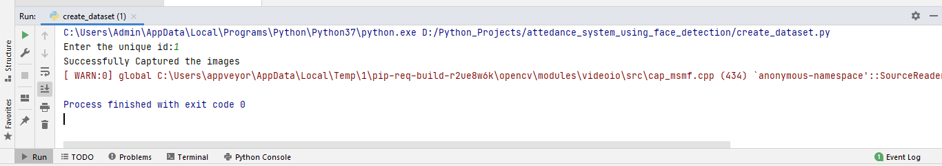

After running this code it will capture the images of a person by using a unique Id and converted from RGB to a grayscale image. We also captured the images of other person but we have to pass the unique Id for each different person.

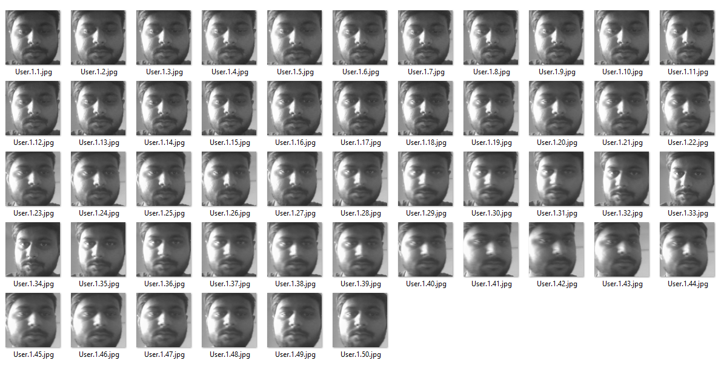

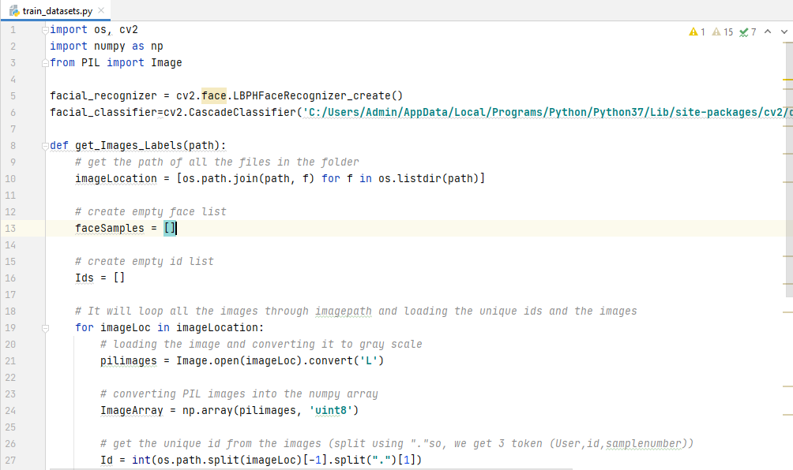**Step 3:** Train the datasets or images that we captured from the previous step. For training the datasets, we use LBPH (Local Binary Pattern Histogram) Algorithm and also the Haar cascade classifier to extract facial features from the images.

**Filename:** train_dataset.py

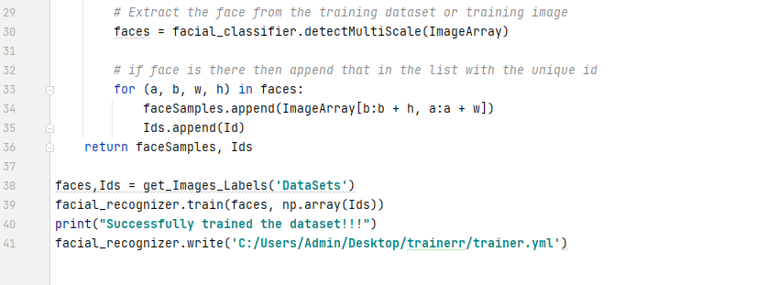

**Output:**

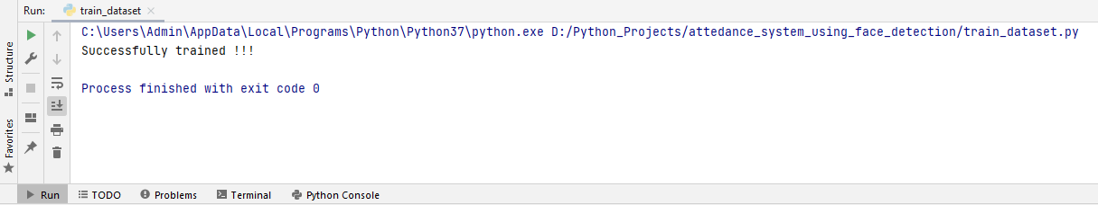

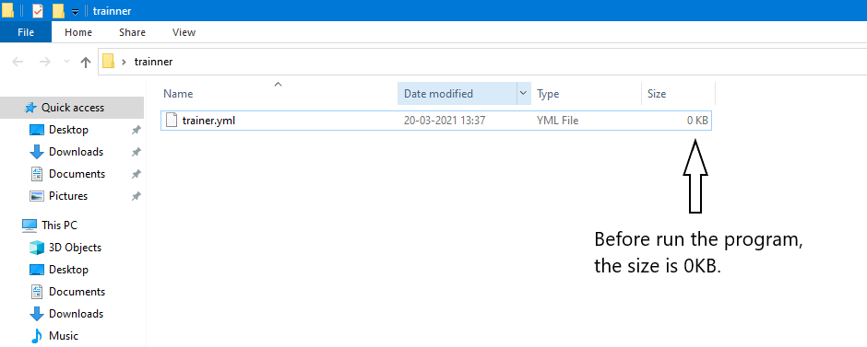

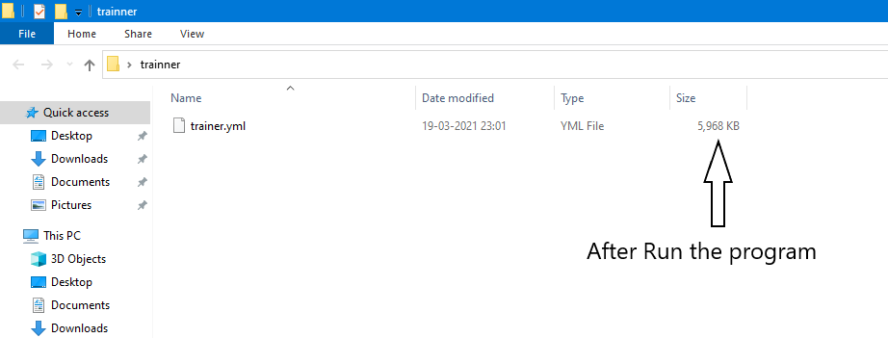

**Step 4:** Now, with the help of this trainer.yml file, we recognise human faces by comparing with already created datasets using a unique ID. If the match is found then it will automatically mark the attendance in the excel sheet along with the current date.

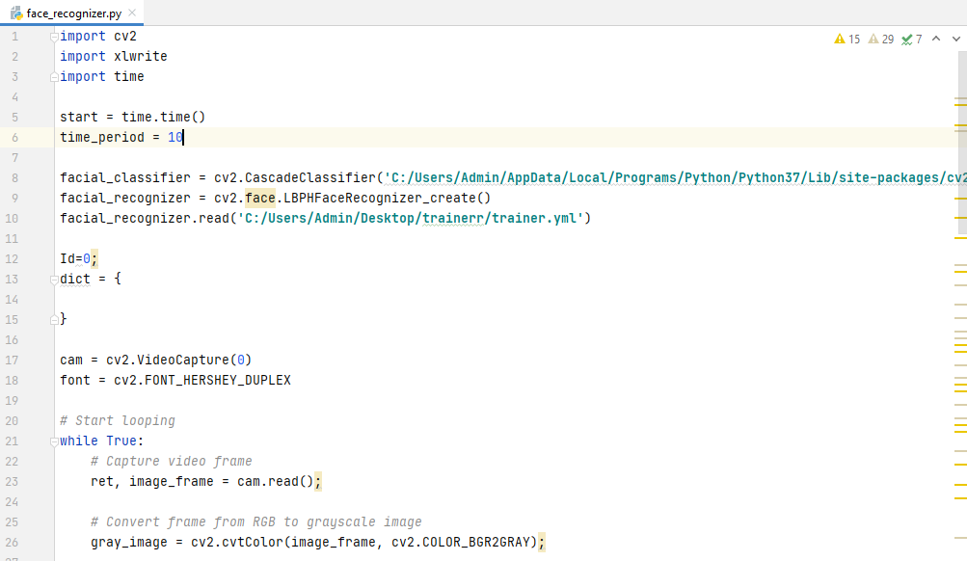**Filename:** face_recognizer.py

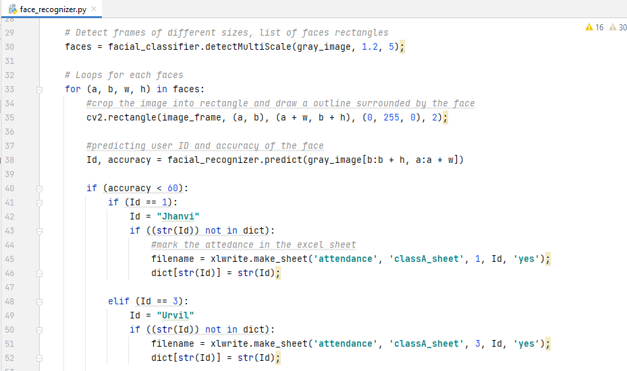

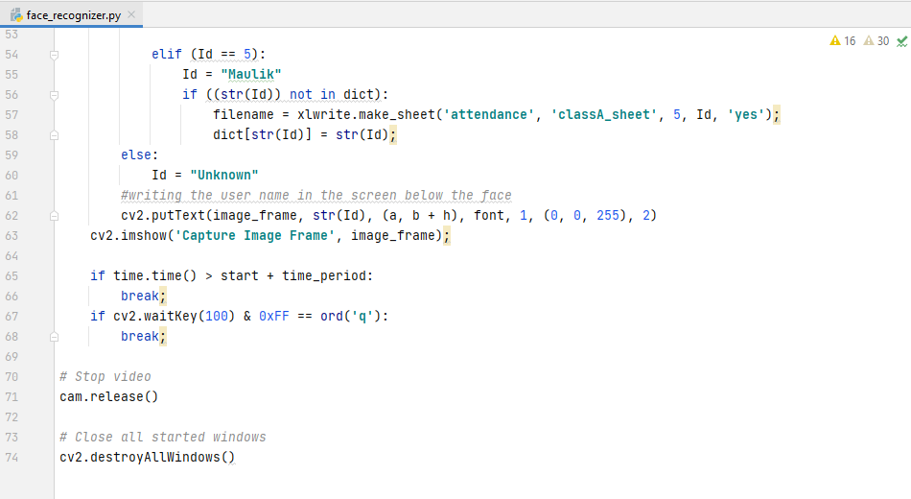

**Step 6:** After the face is found, it will automatically create an excel sheet and mark the attendance based on the face is recognized.

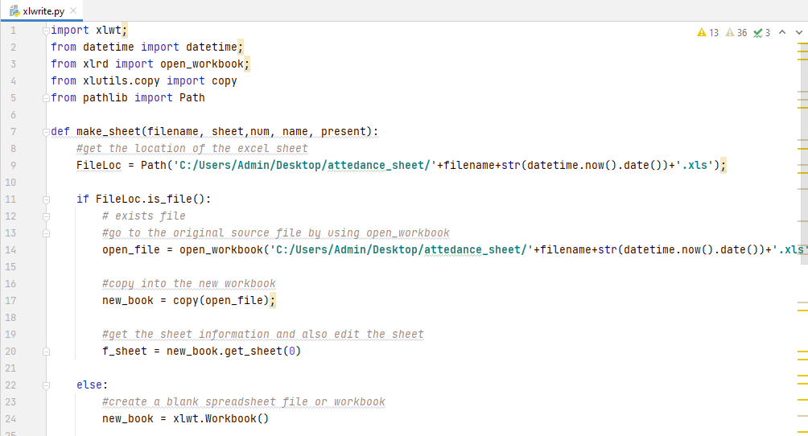**Filename:** xlwrite.py

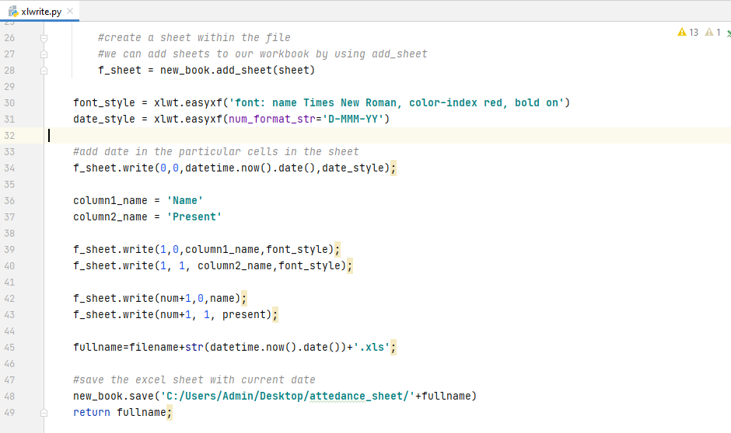

**Output:**

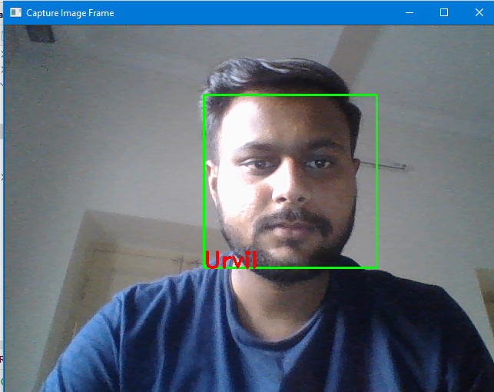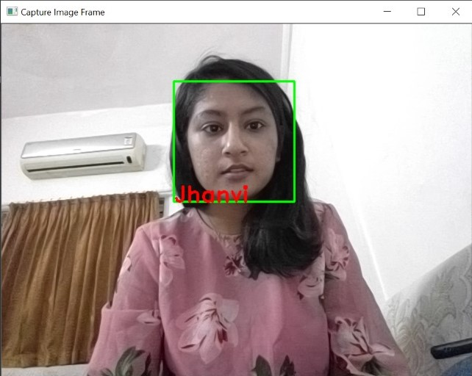

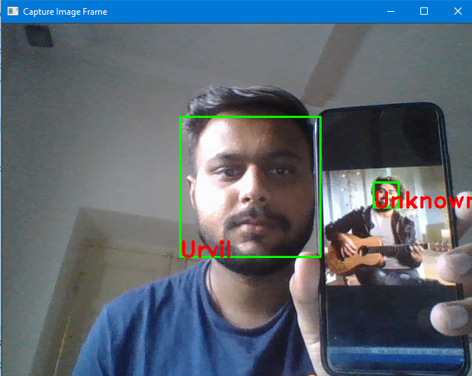



**References:**

* Face detection (image): <https://krazytech.com/technical-papers/face-identification-recognition>
* Face recognition (image): <https://images.app.goo.gl/8g6ENJrs7HEKYsu48>
* Excel sheet logo (image): <https://images.app.goo.gl/ux4UR2qe4twdL51r5>
* Ali Tarhini, “Face Recognition: An Introduction”: [https://alitarhini.wordpress.com/2010/12/05/face-recognition-an-introduction/#:~:text=Image%20acquisition%3A&text=The%20most%20existing%20facial%20recognition,angle%2C%20the%20recognition%20rate%20decreases](https://alitarhini.wordpress.com/2010/12/05/face-recognition-an-introduction/)
* Divyansh Dwivedi, “Face Detection For Beginners” : <https://towardsdatascience.com/face-detection-for-beginners-e58e8f21aad9>